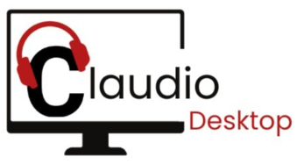


Claudio Desktop Documentation.

Claudio Desktop is a standalone desktop application from Loom Analytics, designed to serve the same purpose as the web-based version of Claudio. Unlike the web version, Claudio Desktop does not require an internet connection for transcription or downloading completed transcripts.

This application is intended for use in one or more of the following scenarios:
- there is limited or no internet connectivity
- the information being processed has security compliance requirements that prohibit use of absolutely any online cloud services

The following instructions will guide you through the basics of using the Claudio Desktop application.

Installation Instructions:

1. To use Claudio Desktop, first create an account on the Claudio Web App. You can sign up by following the instructions here.

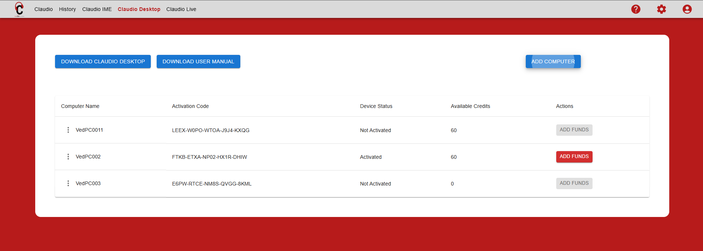

2. After signing up, go to the Claudio Desktop tab on the web app and click ‘Add Computer’. Enter a name for your computer (this will act as an identifier if you add multiple computers later).

When you add a Computer, an Activation Code will appear in the table.
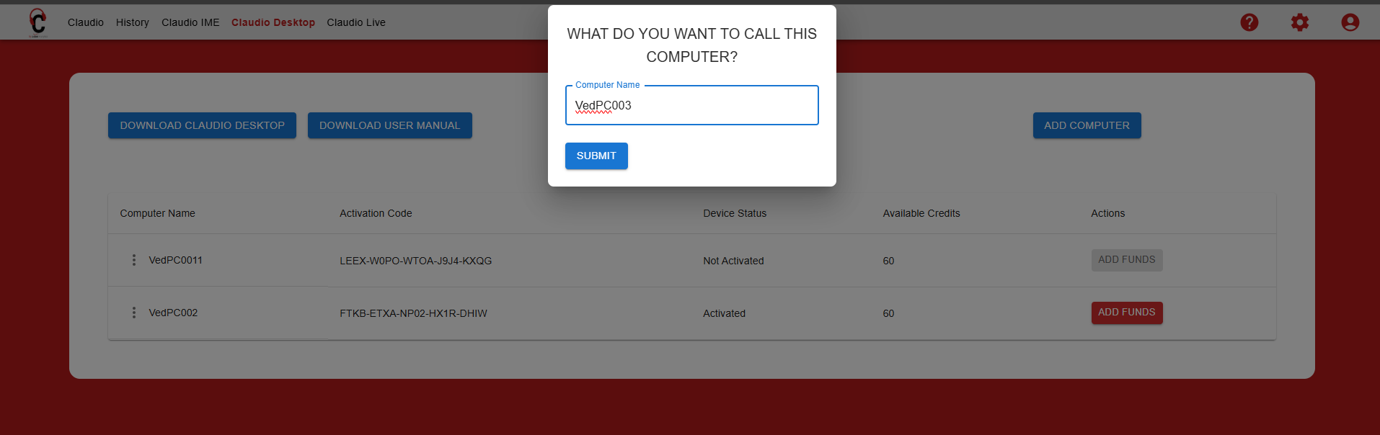

3. Download the desktop application by clicking ‘Download Claudio Desktop’ button.

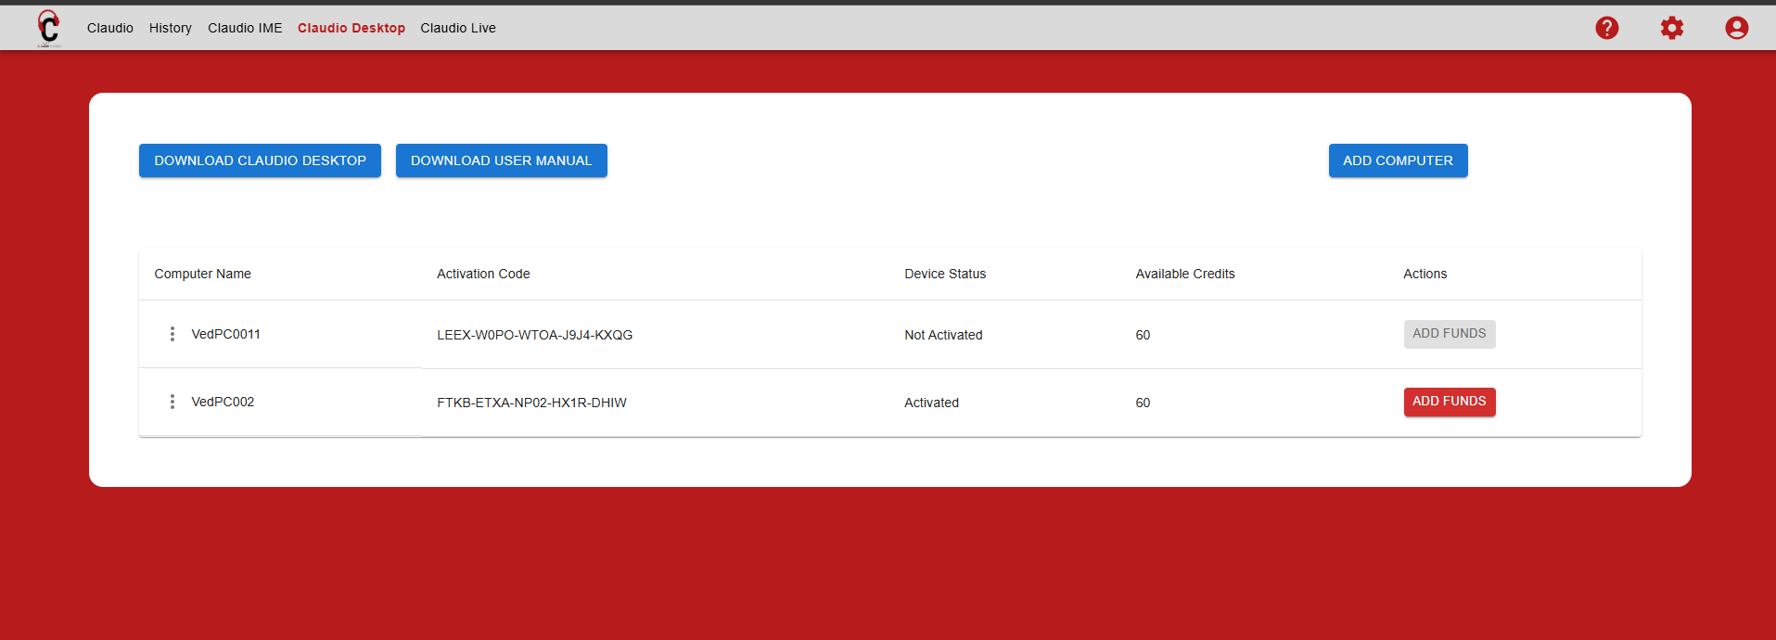

4. After downloading the Desktop app in your specified downloads folder on your computer, double click on the downloaded file.

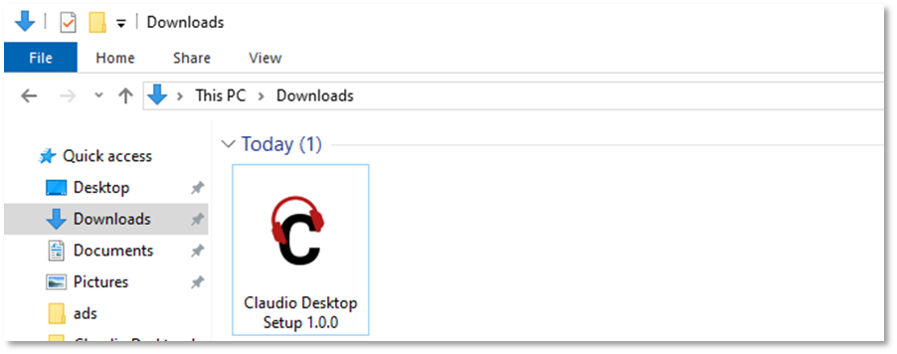

5. A window will open with the License Agreement. Read the agreement and click on ‘I Agree’.

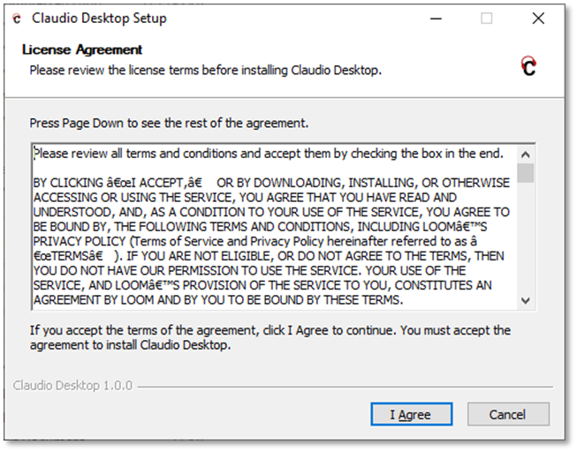

6. Select ‘Anyone who uses this computer’ if there are multiple user accounts on the computer or select ‘Only for me’ if you do not want any other users of this computer to access the application. Click Next.

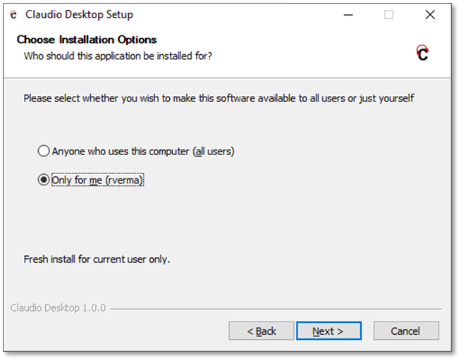

7. Click ‘Install’ and Claudio Desktop will start to install on your computer.
Note: We recommend at least 8 GB available disk space and 16 GB memory.

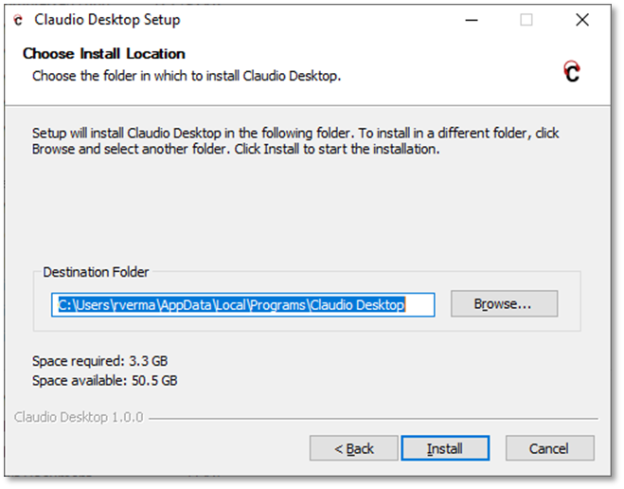
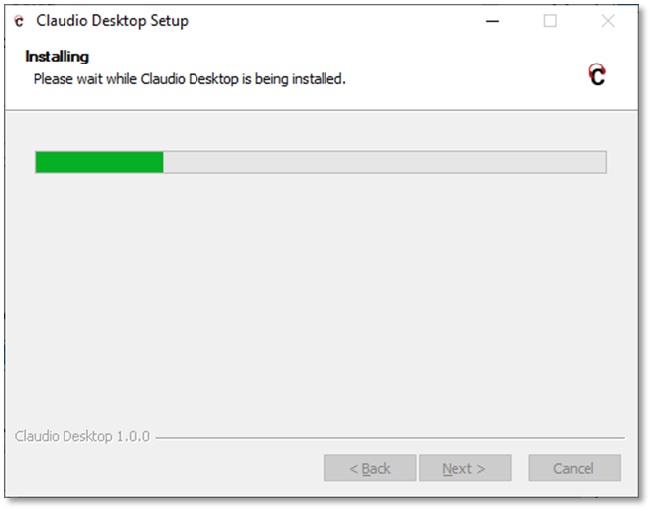

8.1. After installation, click ‘Finish’ and Claudio Desktop will open automatically.

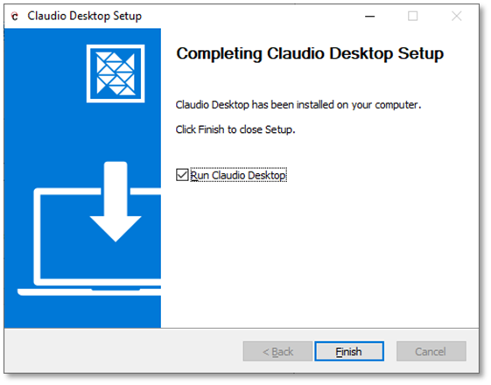

8.2. If it does not open automatically, go to the Start menu and search for ‘Claudio Desktop’ and select the one which says ‘App’ and, Claudio Desktop will open.

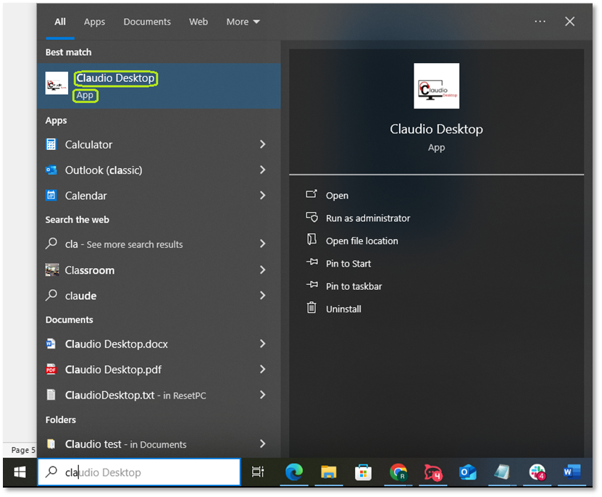

Login Instructions:

Login to Claudio Desktop

1. Open the Claudio Desktop app and log in using the same credentials and region as your Online account.
2. The first time you log in, you'll need an internet connection.

Note: The login username/email and password are the same as your online Claudio account. If you do not remember your password, you can click on Forgot Password to update it. However, you will need an internet connection to do this.

If you do not already have a Claudio Online account and installed this application because the install file was shared with you, you will need to register for an account online before you are able to log into the Claudio Desktop application.

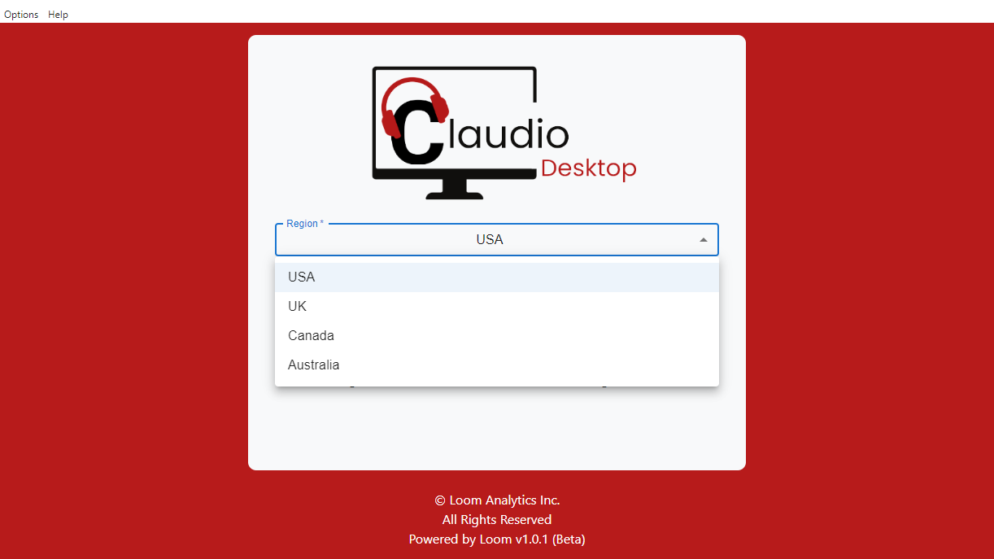

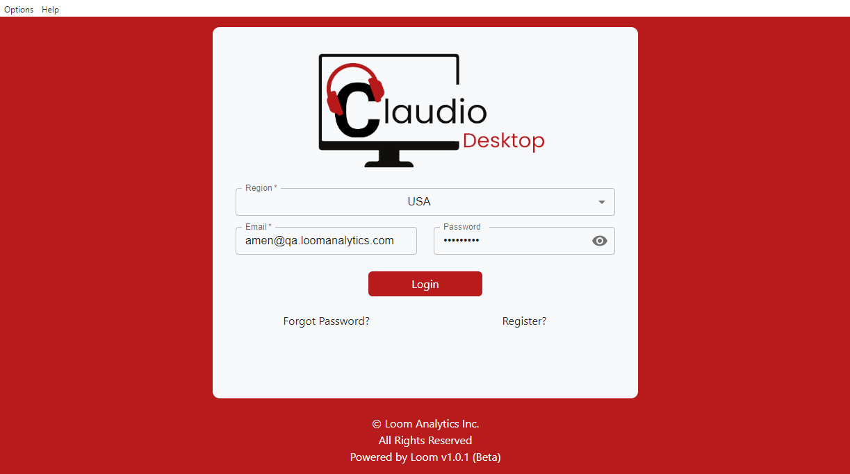

3. After logging in, you will be prompted to enter your Activation Code, which can be found in the Claudio Online account.

4. Go to the Claudio Desktop tab on the Online account and copy the Activation Code.

5. Paste the code into the Claudio Desktop login screen.

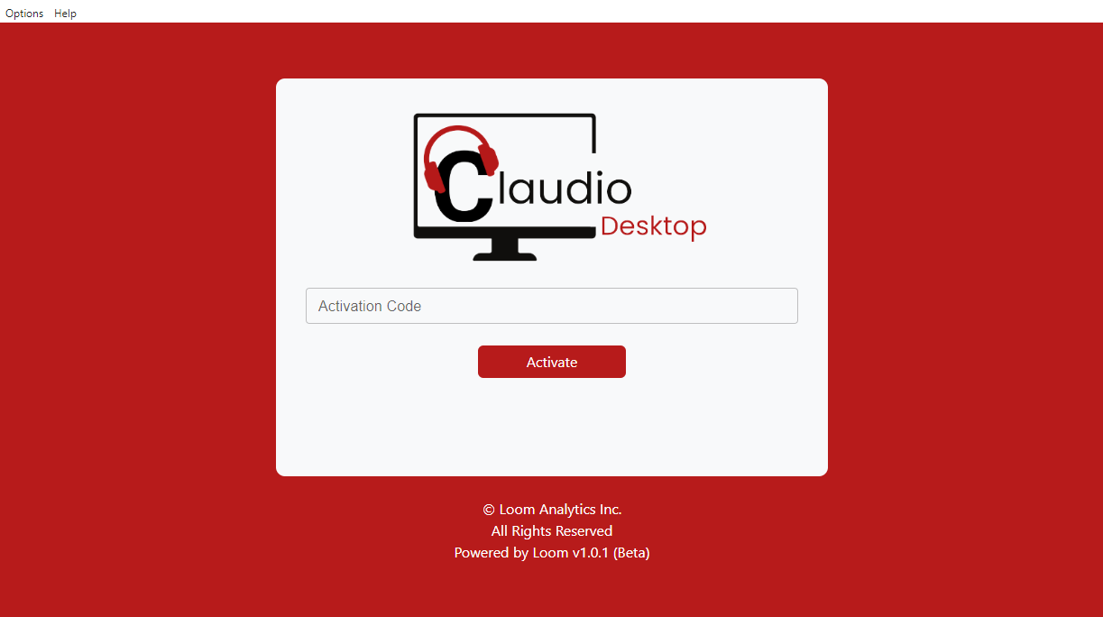

6. Offline Usage - applicable only if you need to use this application in an air gapped environment.

Note: Once logged in, you can disconnect from the internet and continue using the app. You can also log in and out without an internet connection after the initial login process.

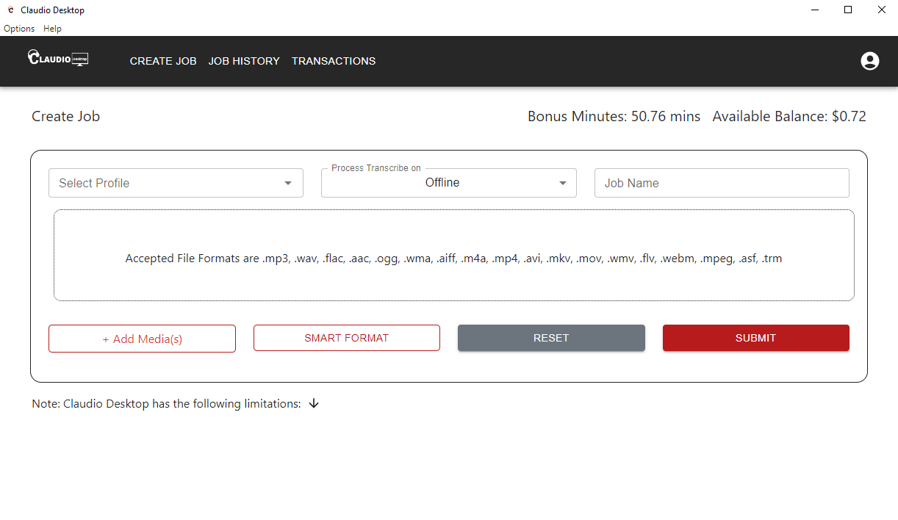

Adding Funds to Claudio Desktop:

To use Claudio Desktop, you need to ensure your account has sufficient funds. Claudio Desktop offers both offline (no internet required) and online payment options:

1. Add Funds via Claudio Online Account
1.1 Follow these steps to add funds to Online account through browser:
a. Open a Browser: Navigate to the Claudio Online website.
b. Log In: Enter your Claudio Online account credentials.
c. Go to the Claudio Desktop Tab: Locate the Desktop section in your account dashboard.
d. Click Add Funds: Select the "Add Funds" option next to your activated computer.
e. Complete Payment: Follow the prompts to complete the transaction. After payment, you will receive a Payment Code via email.

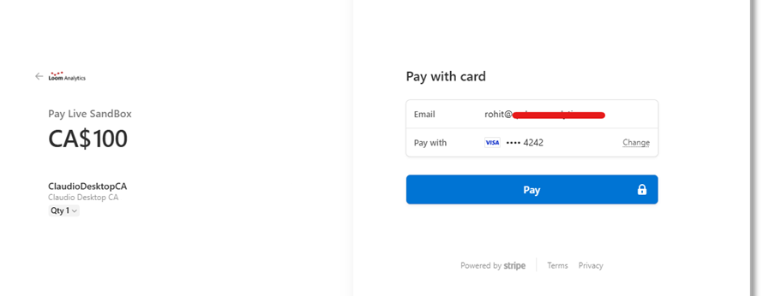

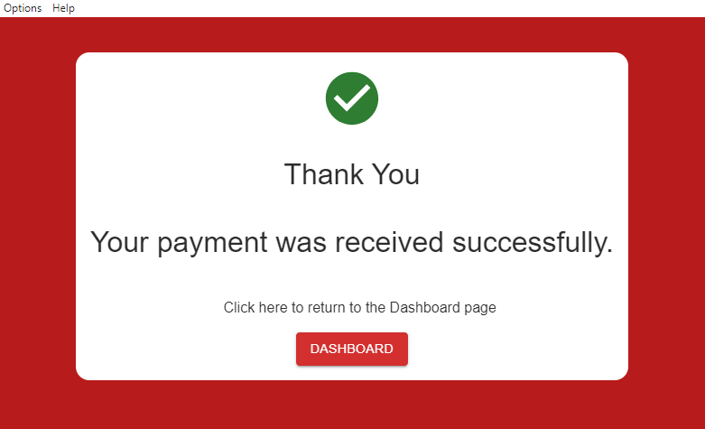

1.2 Follow these steps to add funds to Online account through Desktop Application
- Go to the Payments page from settings to add funds to your Claudio Desktop application.
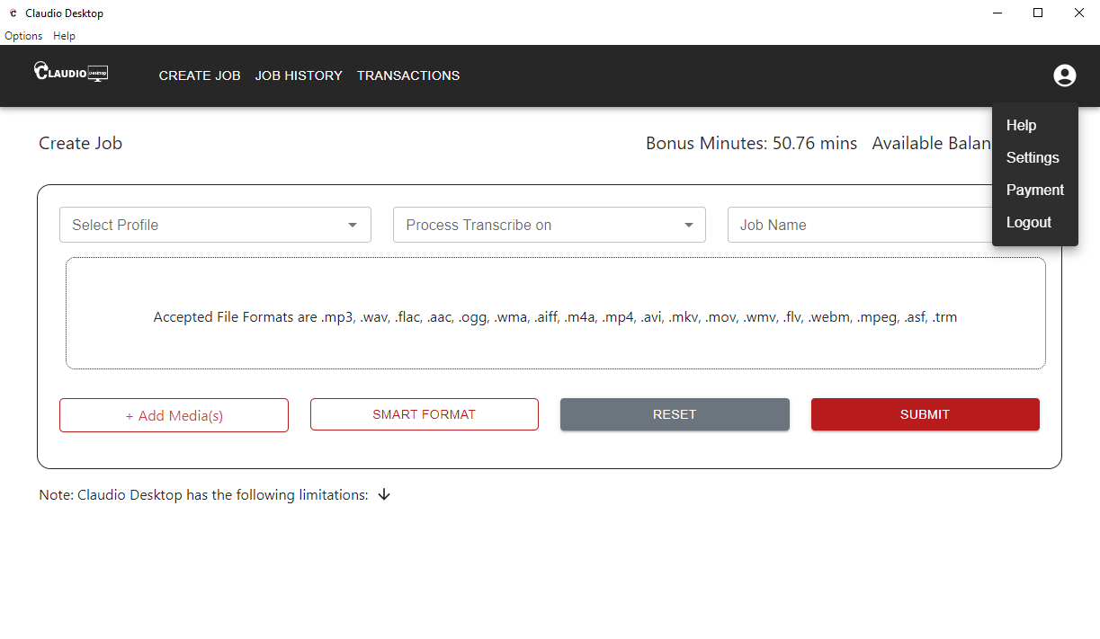
- Click on Pay Online button in Payment’s window
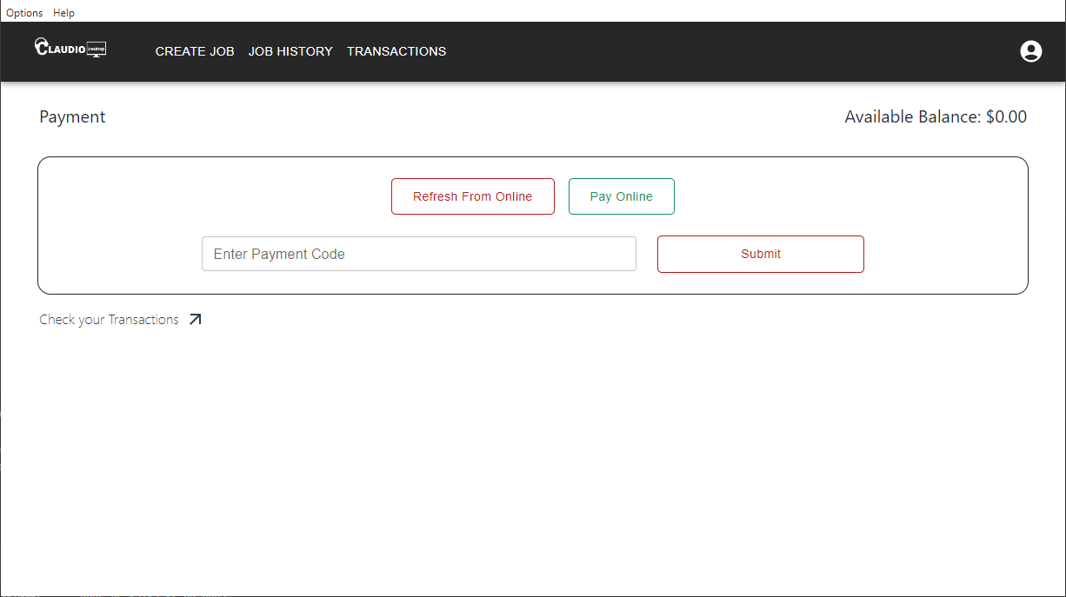
- Login to your Claudio online account and rest of the steps are the same as that of paying through the browser.
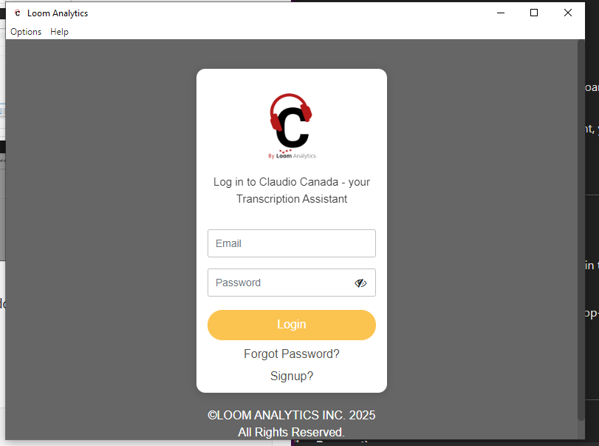

2. Add funds to Claudio Desktop Application

Go to the Payments page from settings to add funds to your Claudio Desktop application.

2.1. Refresh from Online (Online Payment)
You can sync your payment information directly from Claudio Online:
Use the "Refresh from Online" Button: Click the "Refresh from Online" button in the Claudio Desktop app. This will add funds from your online account to Claudio Desktop Application. Internet Connection Required: An active internet connection is necessary to sync payment information successfully.

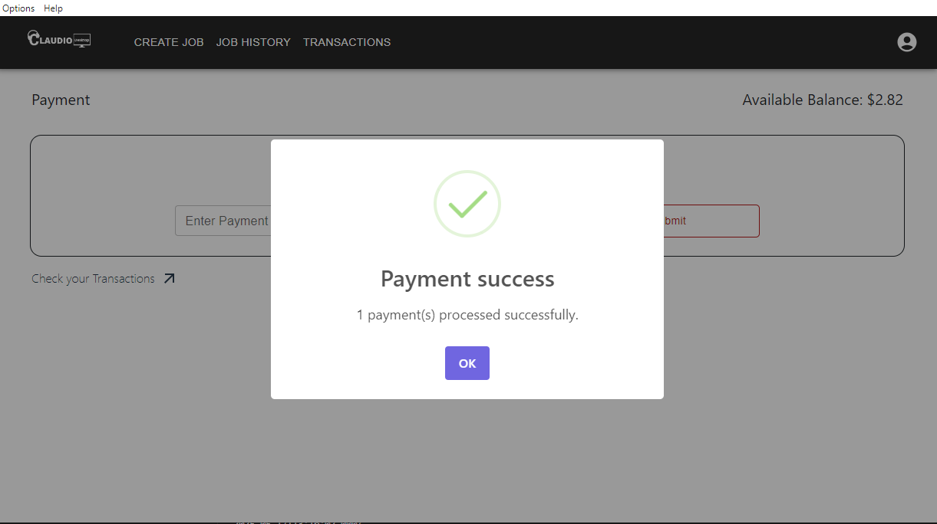

2.2 Add Funds in the Desktop App
Once you’ve obtained your Payment Code in your email, follow these steps to update your credits in the Claudio Desktop app:
a. Enter the Payment Code: Open Claudio Desktop, navigate to Settings (top-right corner), and select Payment. Paste the Payment Code in the required field.
b. Submit: Click the Submit button to update your credits.
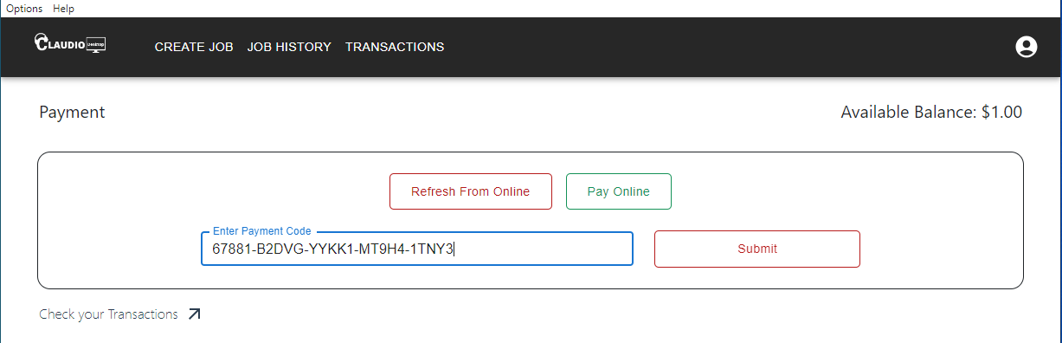
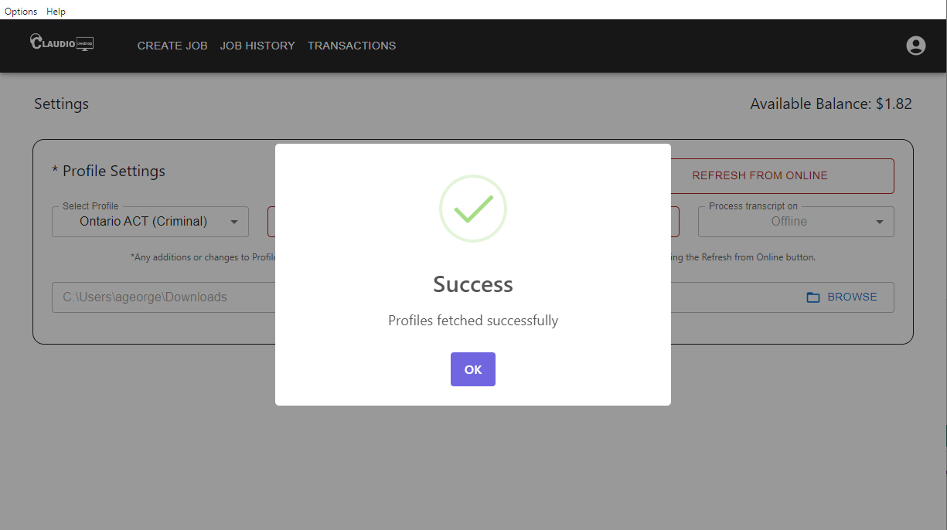

Note: The Available Balance in your Claudio Desktop account will always be visible in the top right corner of the app.

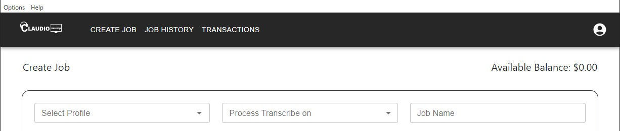

Transactions

Easily track all your usage and transaction history by clicking on Transactions in the top navigation bar or by selecting Payment under your profile settings.

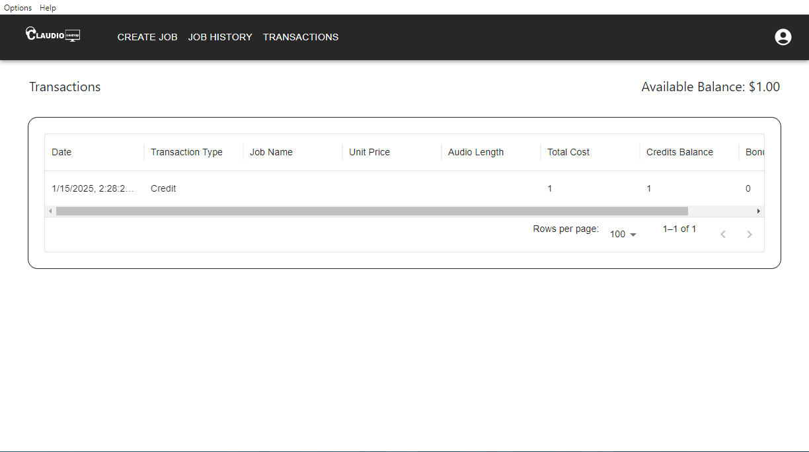

Submitting Jobs (works offline as well):

To submit a transcription job:

- Open Claudio Desktop, click Create Job (the first tab).
- Choose a Profile from Select Profile option.

- Update the Smart Formatting options for your job, then click OK.

Note: The following Smart Format settings are currently not supported on Claudio Desktop
- Grammar-Ready Formatting
- Speaker Labelling
- Audio Events Support
- Closed Captions

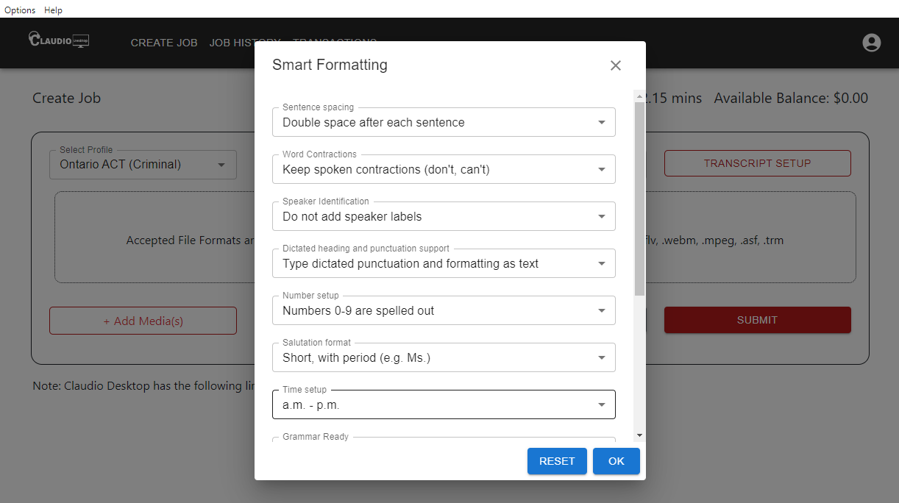

4. Transcript Settings:
- Job Name: Enter a name for your job.
- Transcript Setup: If your profile template has fields that it auto fills for setup, the Transcript Setup button will be active. You can click on it and fill out all the relevant fields required for your document production.

Note: The Ontario ACT profiles support Transcript Setup for all the fields on the cover page.

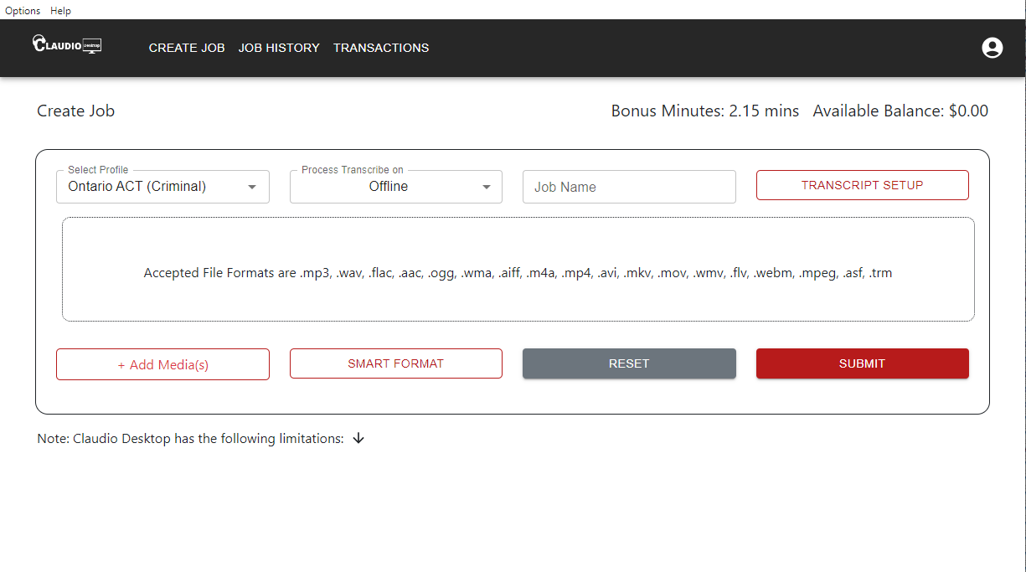

5. Add Media:
You can upload media files in the following formats:
.mp3, .wav, .flac, .aac, .ogg, .wma, .aiff, .m4a, .mp4, .avi, .mkv, .mov, .wmv, .flv, .webm, .mpeg, .asf
Note: DCR, TRM, DSS, DS2, and VOX files are not supported. Please export these files to one of the above-listed formats to submit a job into Claudio Desktop.
Note: Do Not Upload Password-Protected Files
Claudio Desktop does not support transcription for password-protected files. Please remove any password protection before submitting your job to ensure successful processing.
Claudio Desktop allows you to:
- Add Multiple Files: Upload and transcribe multiple files in one job.
- Trim Media: Specify audio start and end points to transcribe only the portions of a file you need. For example, set the start and end times in HH:MM:SS format (e.g., Start: 00:08:00, End: 00:10:00 to transcribe the last 2 minutes of a 10-minute file).
- Change File Order: Rearrange the transcription order by dragging files to your preferred sequence.
- Remove Files: Remove unwanted files from the job before submission by clicking the “Remove” button.
- Reset Submission Form: Reset the submission form and start again with a new form.
- Sort Uploaded File order: When uploading audio files, you can now sort them by clicking on the arrow next to the file list. This makes organizing your files easier and more efficient.
Once all files are added and adjusted as needed, click Submit to begin the transcription process.
6. Submit the Job:
- Once you have entered and verified all the information for the job, click Submit to submit your job and monitor the progress in the Job History tab.

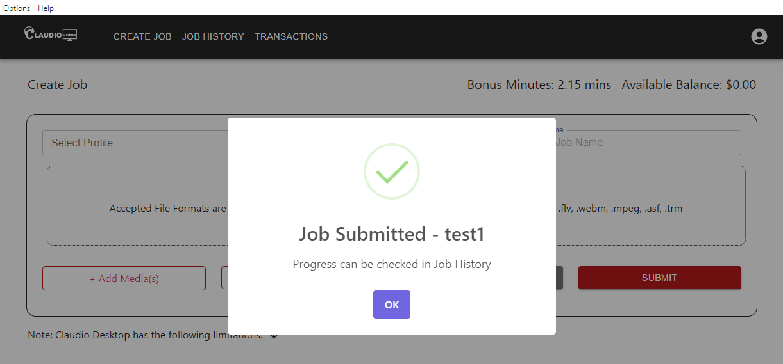

- Once completed, you can access the transcript from the same location where the media file is stored or from the location which is selected by you in the settings.

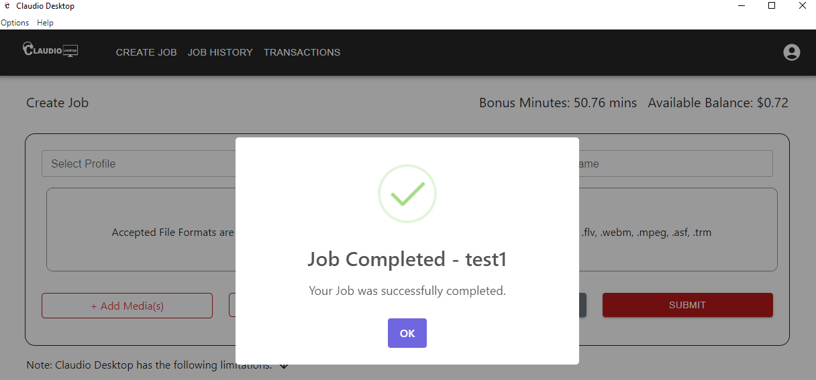

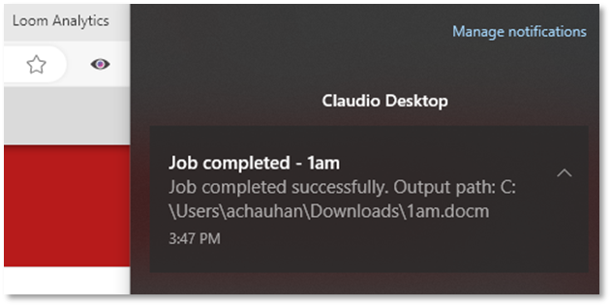

Exiting Claudio Desktop while running a job

When you attempt to exit the Claudio Desktop application while jobs are still in progress, you will see a pop-up notification:

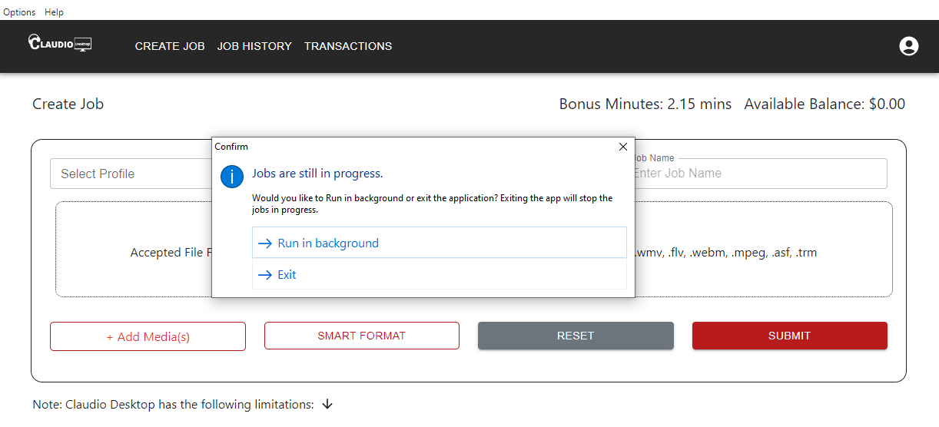

- Run in Background: Choose this option to allow jobs to continue processing in the background. You can access the app later from the system tray (Windows notification area).

- Exit: Selecting this option will cancel all ongoing jobs, and they cannot be recovered.

Once jobs are completed, you will receive a notification in the Windows Notification Center with the output path to access your completed transcripts.
We can see Claudio app running in the background in the windows tray which can be accessed by clicking on the arrow button at the bottom right corner of the windows.

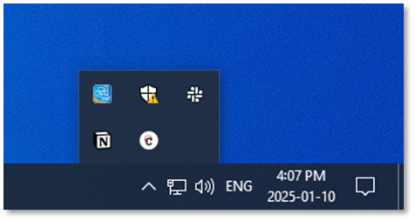

You can double click on the Claudio Desktop Icon to open the application again.

Unexpected App Closure or PC Shutdown:

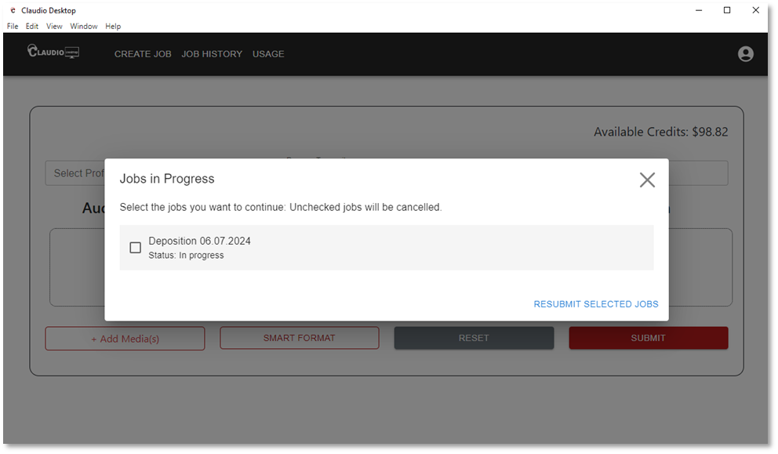

- Transcription jobs will fail if the app closes unexpectedly, or the PC shuts down during processing.
- Upon restarting the app, a pop-up notification will appear prompting you to resubmit and resume selected jobs.
- If the resume option is cancelled, the job cannot be recovered.
- During the resume process, if no action is taken or required jobs are left unselected, those jobs will be automatically cancelled.

Settings in Claudio Desktop:

In the Settings tab of the Claudio Desktop app, you can:

- Change the Download Location for your transcripts.
- If you have access to manage your own profiles, you can create and edit them in your Claudio online account and update the changes to your Desktop app by clicking on the Refresh from Online button.
- Preview the Template and Smart Format settings associated with your profile.

- Change Download Location:

By default, completed transcripts are saved in the same folder as your uploaded media file. To change the save location:

1.1 Go to Settings: Click Settings in the top-right corner of the app.

1.2. Select Profile: Choose the profile for which you want to change the download location.

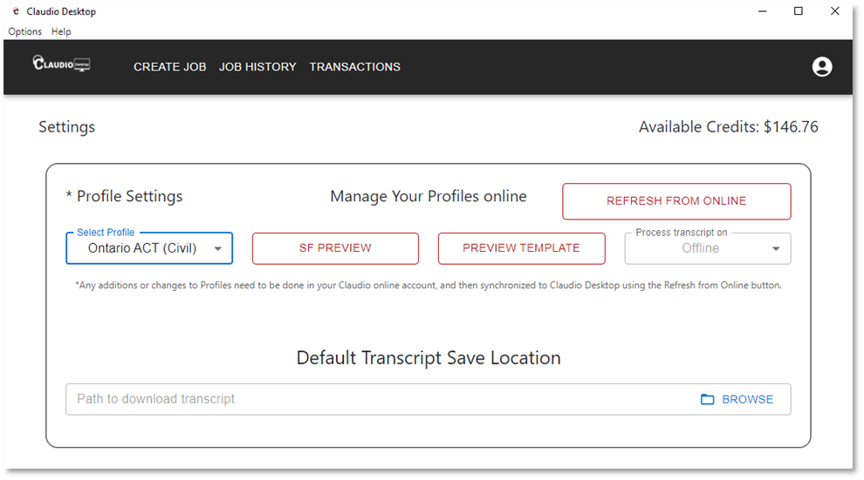

1.3. Set Default Save Location:
Click Browse to choose a new folder where completed transcripts will be saved.

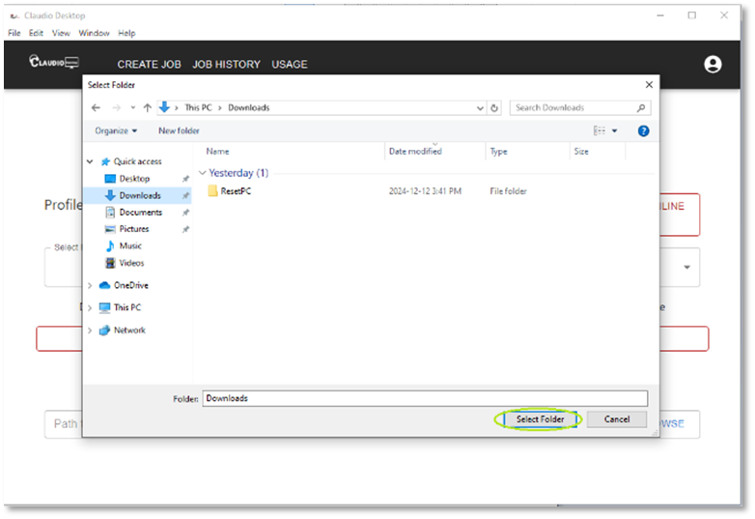

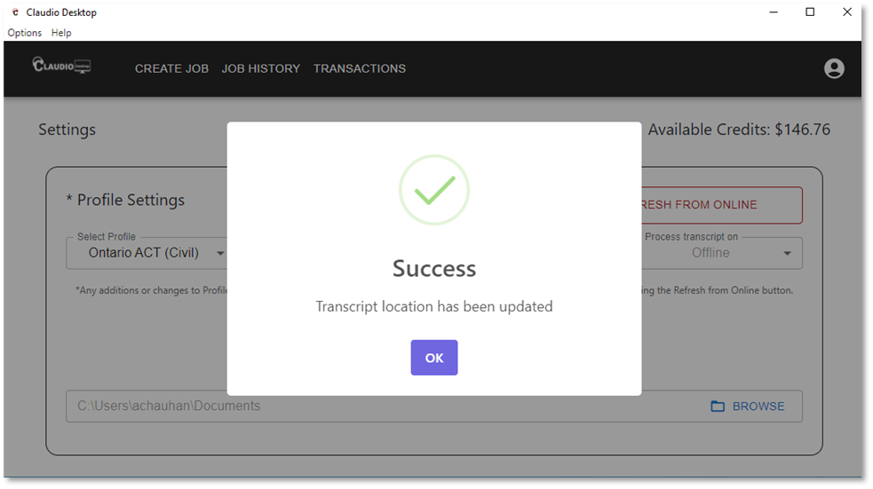

- Refresh Changes from Your Claudio Online Account:

To update your profiles with changes from your Claudio Online account:
2.1. Go to Settings: Click the Settings icon in the top-right corner of the app.

2.2. Refresh Profiles:
- Click ‘Refresh from Online’.
- A message will appear saying Profiles Fetched Successfully.
- Click OK and wait for a minute while the changes are reflected.

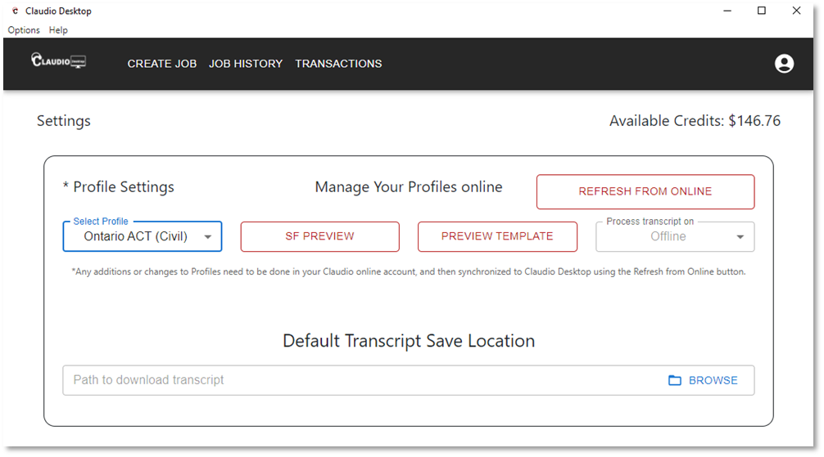

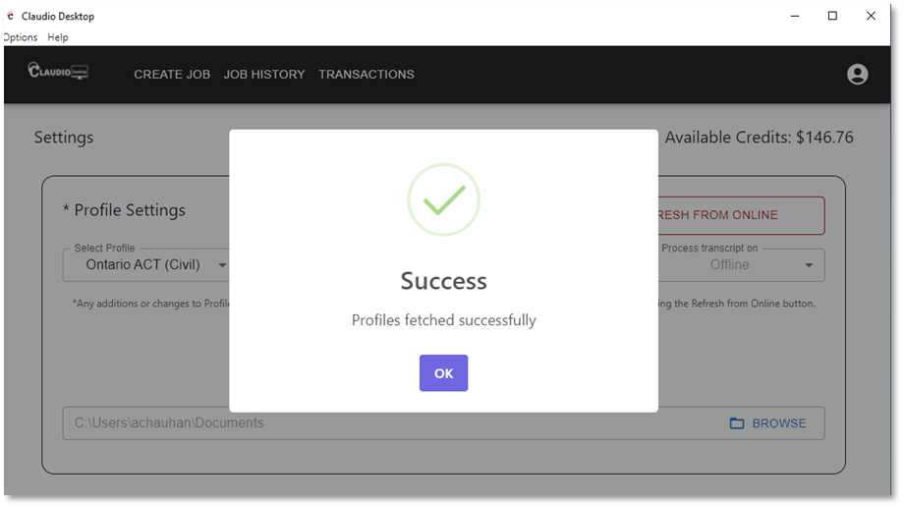

- Preview the Template:

To view the template for your selected profile:

3.1. Go to Settings: Click the Settings icon in the top-right corner of the app.

3.2. Select Profile: Choose your profile from the list.

3.3. Preview the Template:
- Click the Preview button under the View Template option.
- A new MS Word window will open, displaying the profile's template preview.

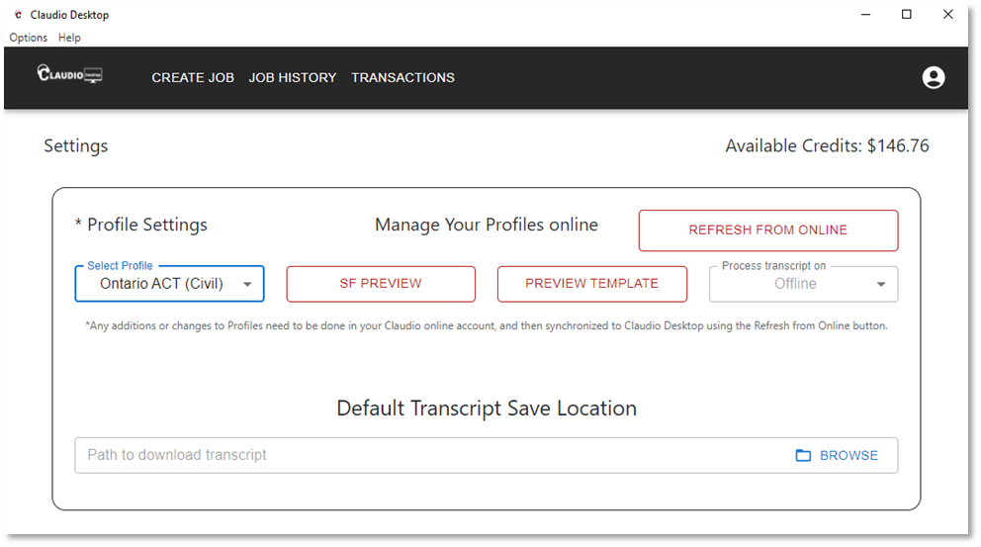

- Preview of the Smart Format Settings:

To preview the Smart Format settings for your profile:

4.1. Go to Settings: Click the Settings icon in the top-right corner of the app.

4.2. Select Profile: Choose your profile.

4.3. Preview Smart Format:
- Click the Preview button under the Default Smart Format Setting option.
- A preview of your profile's Smart Format settings will open, showing the available formatting options.

Uninstall Claudio Desktop
There are two simple ways to uninstall Claudio Desktop:
- Using Control Panel:
- Go to Control Panel > Programs > Uninstall a Program.
- Find "Claudio Desktop" in the list, select it, and click Uninstall.
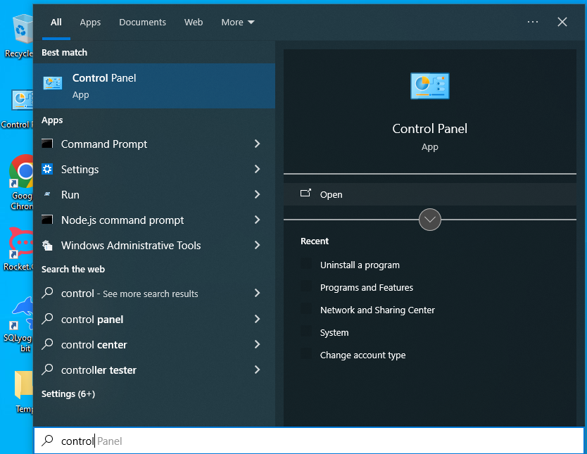
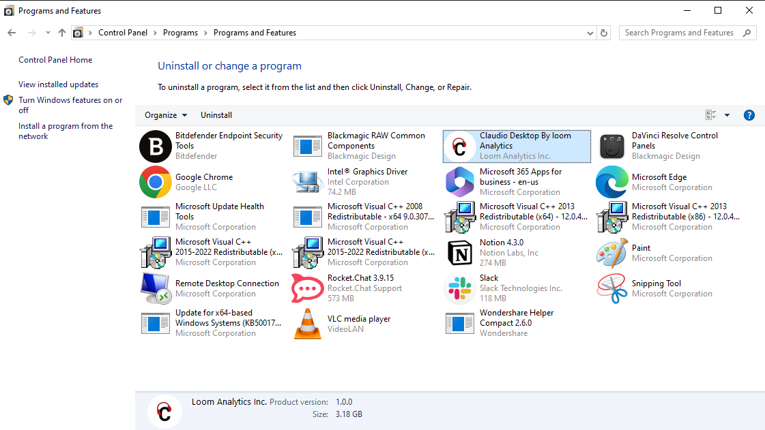

- Using the Search Bar:
- Search for "Claudio Desktop" in your computer’s search bar.
- Right-click on the app and select Uninstall. This will open the control panel from where you can uninstall the application.
- 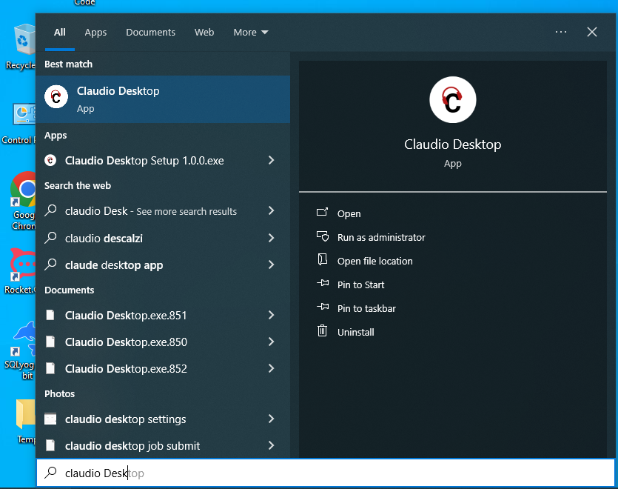
When uninstalling, you can choose between two options:

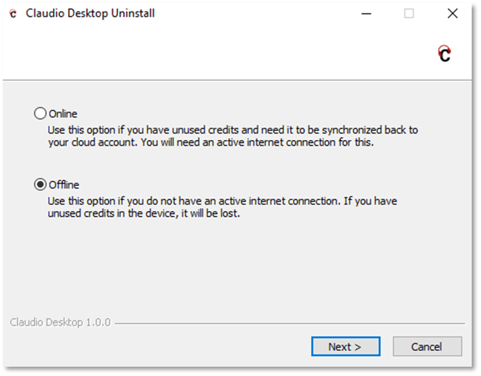

- Online Uninstall:

- Use this option if you have unused credits that need to be synchronized back to your Claudio online account.
- An active internet connection is required for this process.
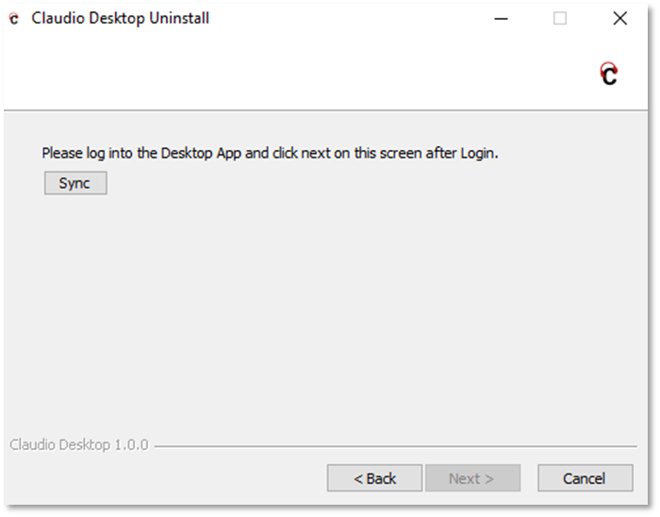

- Offline Uninstall:

- Use this option if you do not have an active internet connection.
- Please note: Any unused credits stored on the device will be lost.

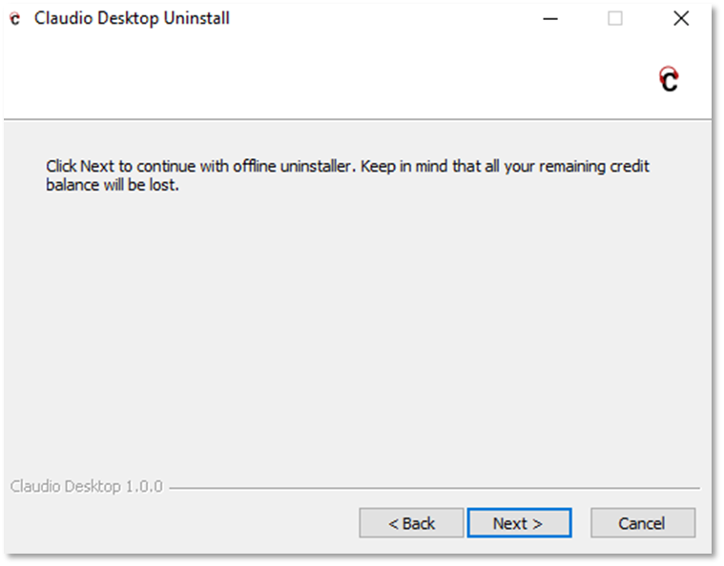

When to Connect to the Internet:

You will need an internet connection in the following scenarios:

1. First-time Login or Signup:
An internet connection is required when logging into the app for the first time or signing up for a Claudio Online account.

2. Uninstalling the Desktop App:
An active internet connection is required when uninstalling the Claudio Desktop app, if you have an unused balance on your computer that you need to synchronize back to your Claudio Online account.

3. Refreshing Payment additions from Claudio Online Account:
An active internet connection is required to refresh and sync payment information or any updates from your Claudio Online account to the Desktop app, if you want to avoid entering the Payment code manually.

4. Refreshing Profile Changes from Claudio Online Account:
An internet connection is needed to refresh and sync changes from your Claudio Online account to the Desktop app.

Limitations of Claudio Desktop:

- Slower Transcription Speed:
Claudio Desktop relies on the processing power of personal computers. This means transcription times can be slower compared to cloud-based Claudio Online. For instance, transcribing one hour of audio may take up to 40 minutes.

Limited File Format Support
Claudio Desktop has restricted file format compatibility compared to Claudio Online:
- No DCR Conversion Support: Digital Court Reporter (DCR) file conversion is not supported.
- No Voxlog Support: Voxlog files are incompatible with Claudio Desktop.
- No DSS and DCT Support: While Claudio Online supports DSS and DCT file formats, these are not available on Claudio Desktop.
- Grammar-Ready Formatting:
Grammar-ready formatting is not currently supported.

- No Speaker Labeling:
Speaker labels are not available in the desktop version.

- Limited Profiles:
Claudio Desktop has a limited selection of profiles and currently only supports non-medical profiles. Medical profiles are not available currently. If you upload files with medical terminology, please expect a blank or poor-quality transcript.

- No Audio Events Support:
Audio event detection (e.g., identifying claps, music, coughs, or interruptions) is not supported.

- No Closed Captions:
The desktop version does not currently generate closed captions for audio or video files.

- Limited Language Support:
Claudio Desktop supports transcription exclusively in English, with the following regional variations:

- English (United States)
- English (Canada)
- English (United Kingdom)
- English (Australia)
- Other languages are not supported currently.

These limitations ensure that Claudio Desktop operates entirely offline, providing maximum security for sensitive data while still delivering high-accuracy transcripts and customizable templates. For users who require advanced features like grammar-ready formatting, speaker labeling, or faster transcription times, Claudio Online and Claudio Live offer additional functionality while maintaining robust security measures.

Support:
- If you receive an email offering free minutes but do not see them reflected in your account, please contact sales@loomanalytics.com for assistance.
- Learn more, visit Claudio Desktop.
- Need help? Check out the Knowledge Base for all support articles.

